Group assignment answer sheet for Lab test 1
Student ID | Student Name
14657314 | Jinkyung Kim
25743535 | Maroor Chethan Pai
25652177 | Harshit Kalpesh Soni
25739069 | Preetham Srinivas
25533100 | Sreelakshmi Nambiar
Note: each group only submit one answer sheet. Do not submit it multiple times! When you finish the assignment, attach this file to an email, send it to your lead tutor, and cc to your group members.
Question: Set up static networking for your CentOS and a dynamically assigned IP address for your Windows Server given the following parameters:
 | Our network | CentOS | Windows Server
IP addressing: | 10.0.2.0/24 | 10.0.2.1 | DHCP assigned
Interface: |  | ens192 | Ethernet1
DNS Suffix or  Search Domain: |  | it.uts.edu.au | it.uts.edu.au
Hostname |  | Linux | Win
Gateway: |  | 10.0.2.1 | DHCP assigned

Provide a screenshot of each command.
CentOS
1. cat /etc/hostname

2. cat /etc/resolv.conf

3. route -n
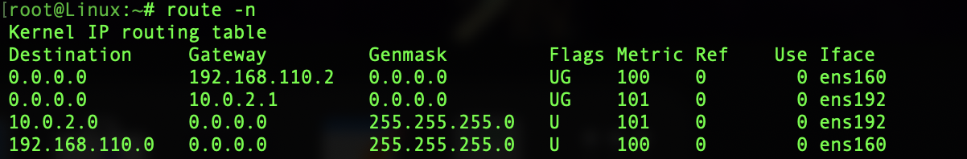
4. ifconfig ens192
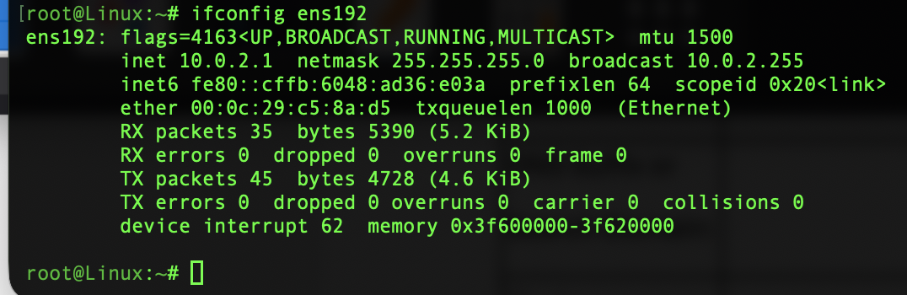

Windows Server
ipconfig /all
